# Assignment 3: Building Your Freelancing Experience Through Strategic BiddinG

# Hamza(8628-B)

## 1) Platform Setup

Platform Profiles:

I have created professional profiles on Freelancer.com, Guru, and Truelancer as required.

Profile 1: Freelancer.com  
Main Heading: Design-Driven Full-Stack Development

Bio Snippet:

Hello! I’m a Full Stack Developer & UI/UX Designer with strong skills in React, React Native, Node.js, Express, MongoDB, MySQL, and modern design tools. I create clean, responsive, and high-performance applications with a strong emphasis on user experience, system requirements, and clear communication.

I specialize in transforming ideas into complete digital solutions by following a structured process: requirements gathering, analysis, wireframing, UI/UX design, development, testing, and delivery. My goal is to build applications that not only work smoothly but also look great and solve real problems for users.

My Core Skills: -

Frontend Development: React.js, React Native, --JavaScript, HTML5, CSS3, Tailwind, Bootstrap

-Backend Development: Node.js, Express.js, REST API development

-Databases: MongoDB, MySQL

-UI/UX Design: Figma, Wireframes, Prototypes, User Flows, Modern UI Layouts

-Requirement Gathering: Understanding client needs, drafting features, scope clarification, workflow mapping

-Analysis & Planning: Use cases, feature breakdowns, architecture planning, project estimations

-Other Tools: Git, GitHub, Postman, Expo, VSCode

Profile 2: Guru.com

Headline: : Design-Driven Full-Stack Developer

Bio: "Same as freelancer."

Profile 3: Truelancer.com

Headline: Design-Driven Full-Stack Developmer

Bio: “’m a Full Stack Developer & UI/UX Designer with expertise in React, React Native, Node.js, Express, MongoDB, MySQL, and modern design tools. I build responsive, high performance web & mobile applications with a focus on smooth UX and clear requirements. I handle complete projects—from requirement gathering and wireframing to UI/UX design, development, testing, and deployment. I also create APIs, admin dashboards, e commerce systems, and landing pages. I ensure clean, scalable code, timely updates, and effective communication. Let’s turn your ideas into functional, visually appealing digital solutions!”

## 2) Bidding Log:

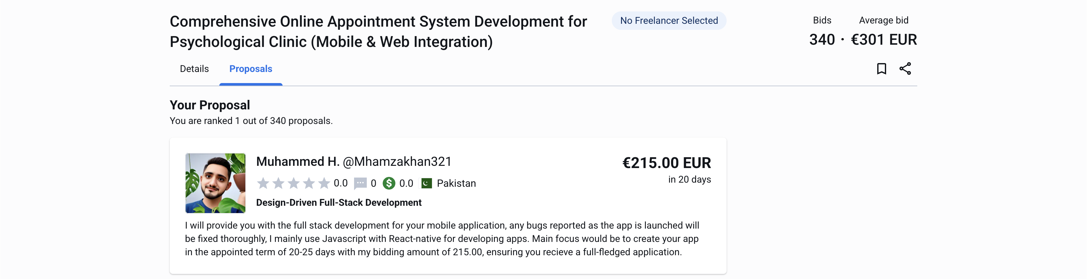

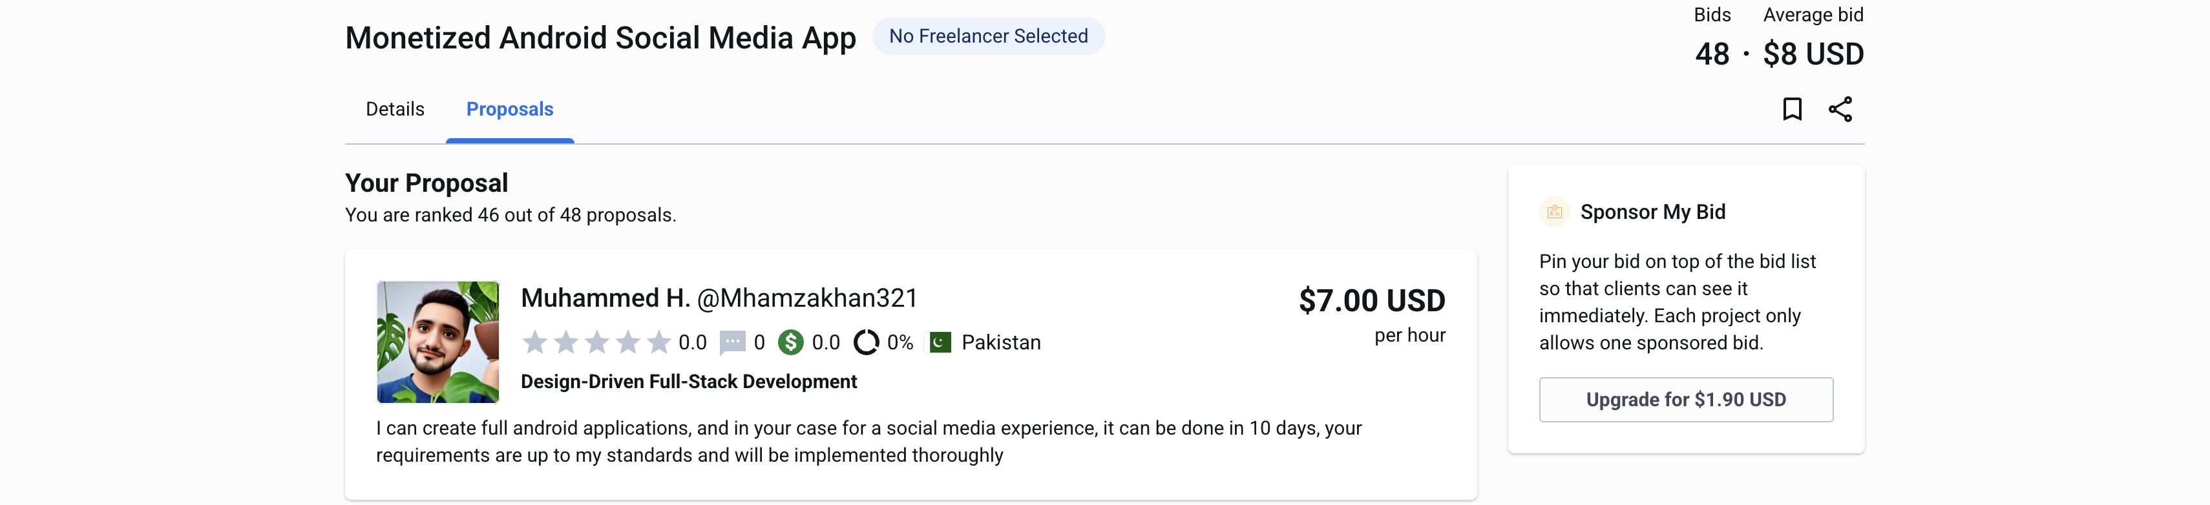

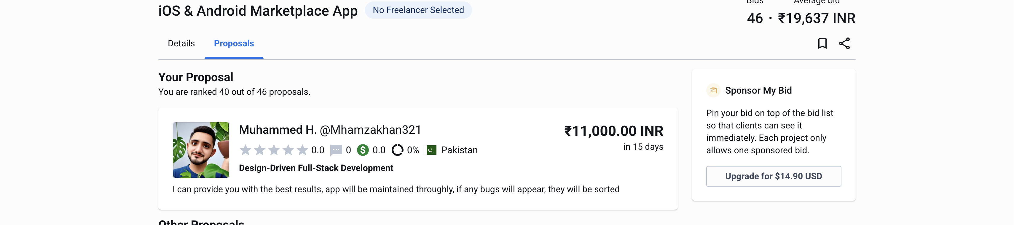

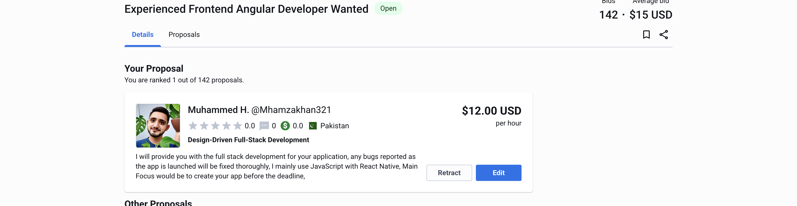

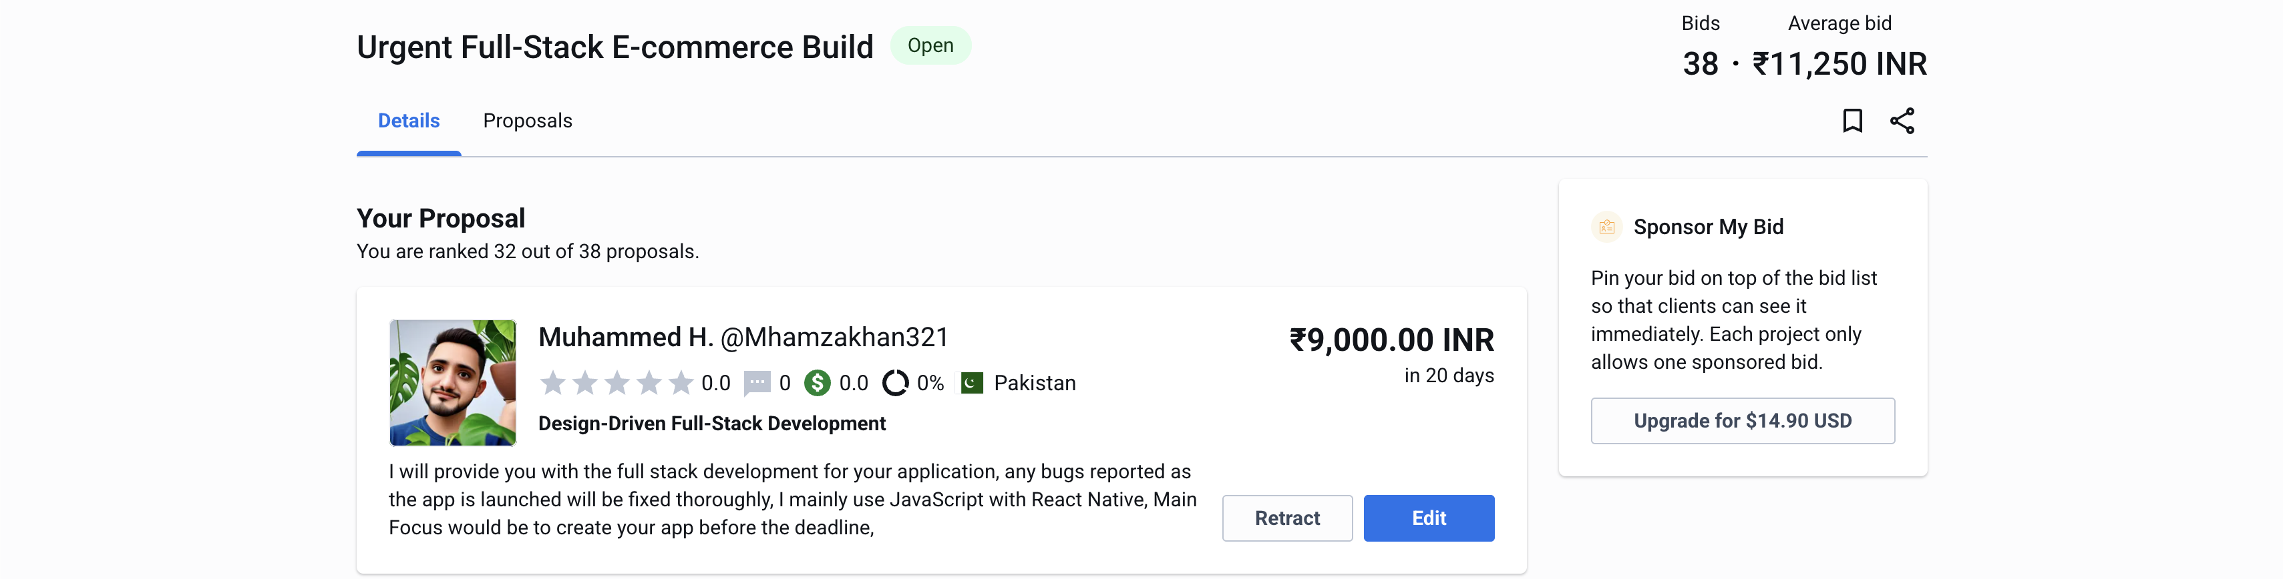

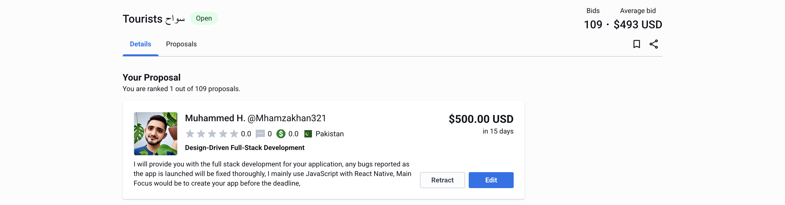

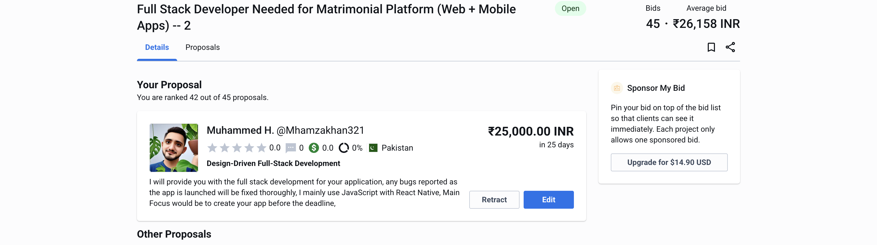

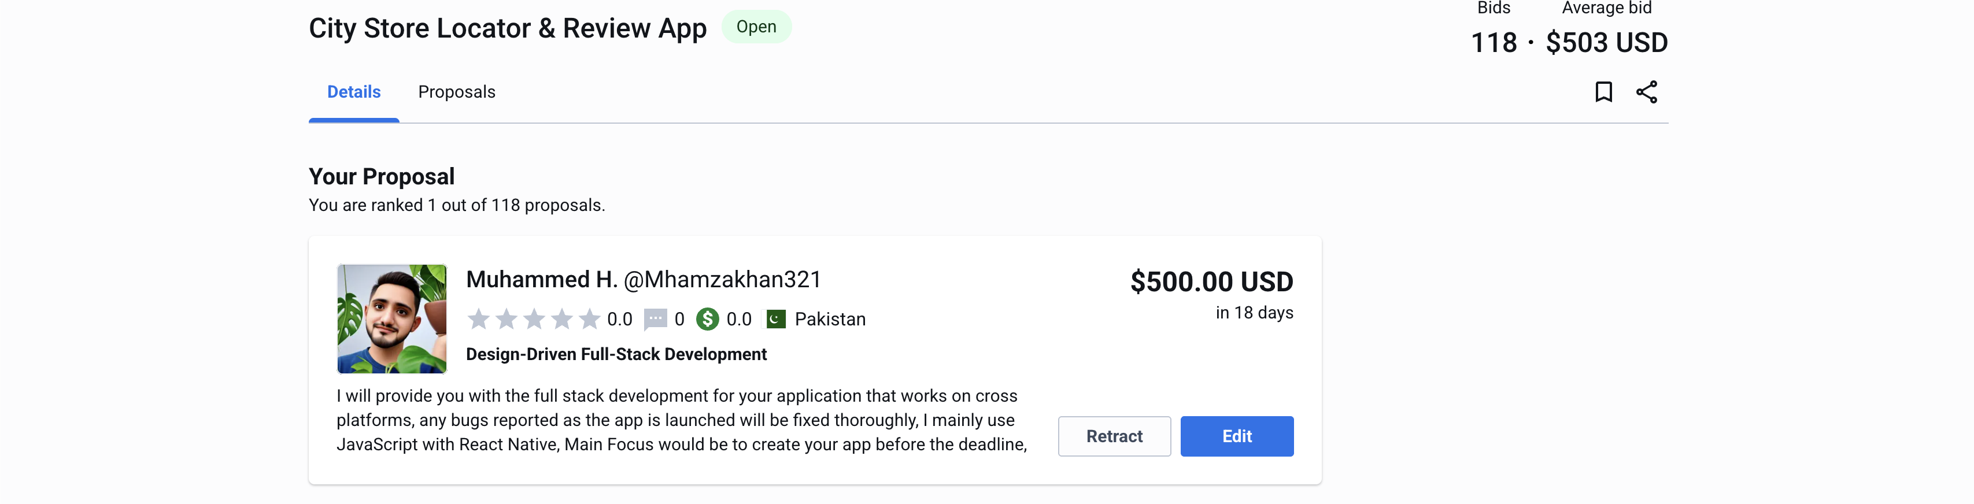

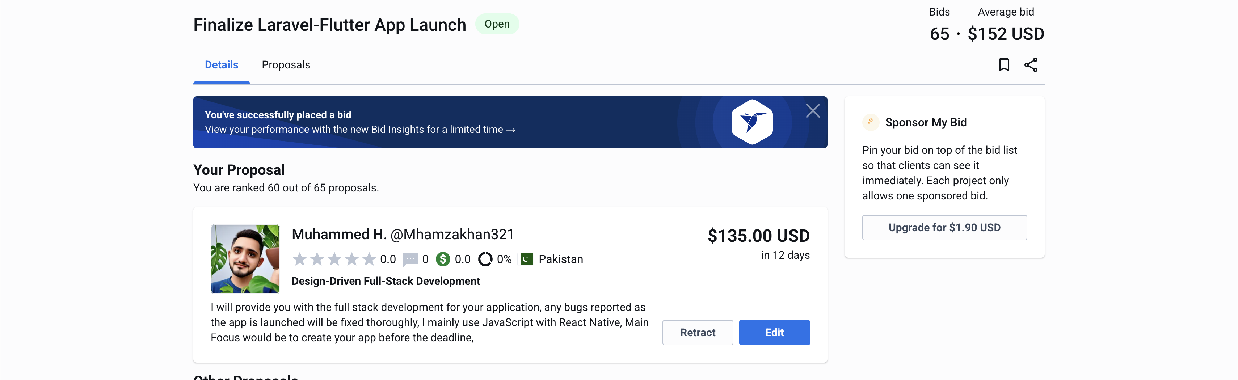

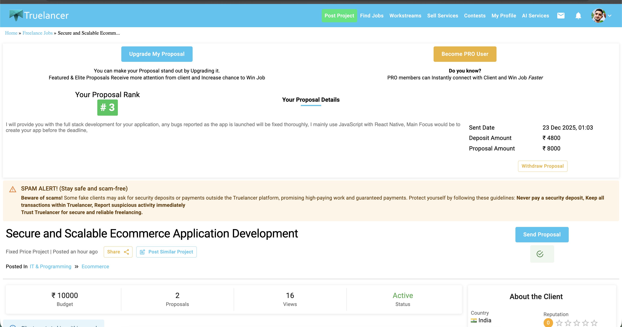

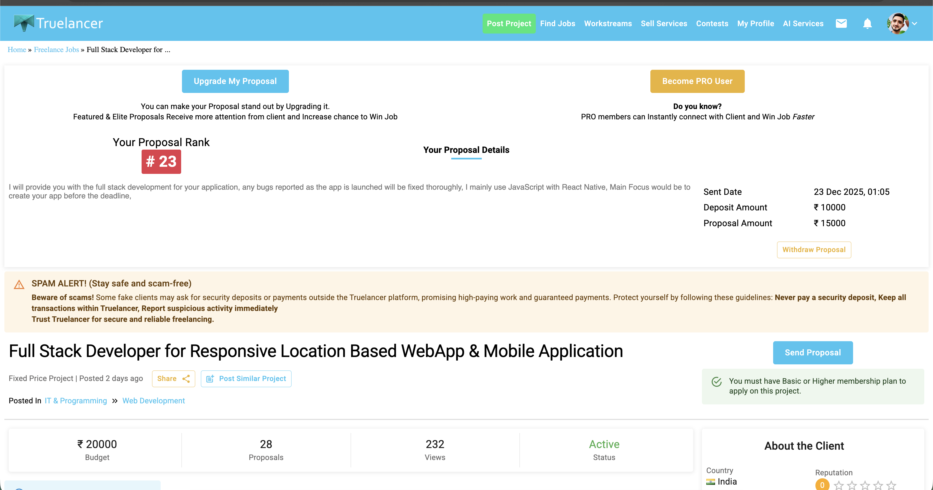

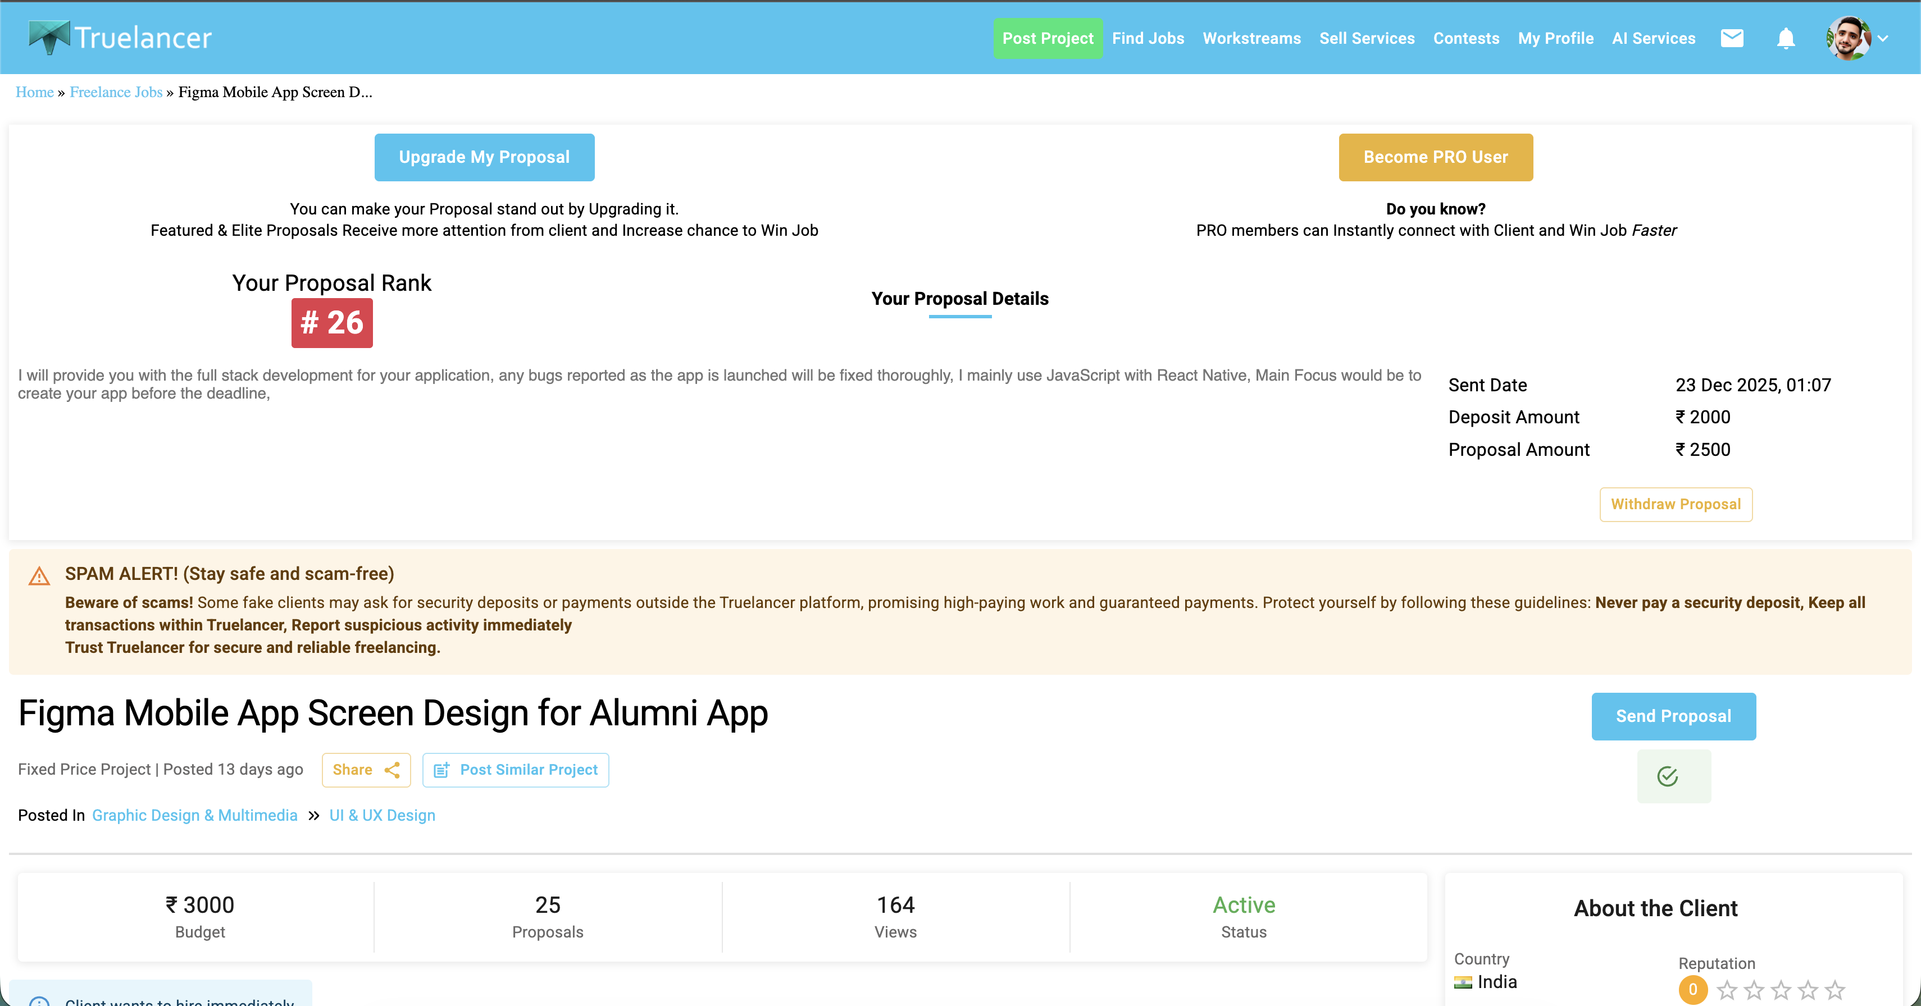

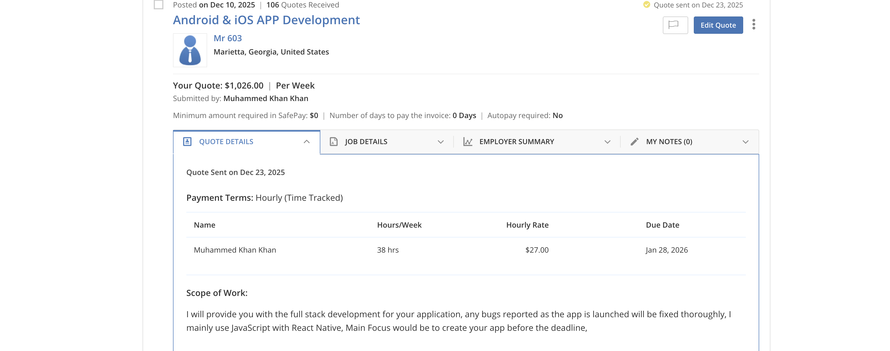

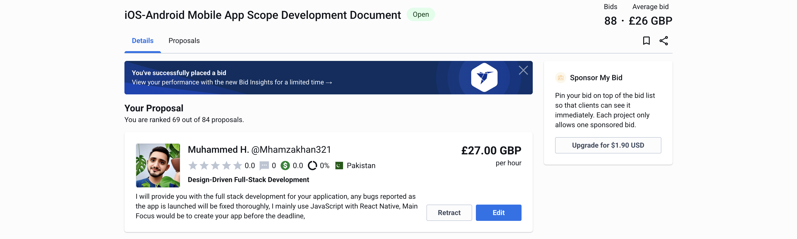

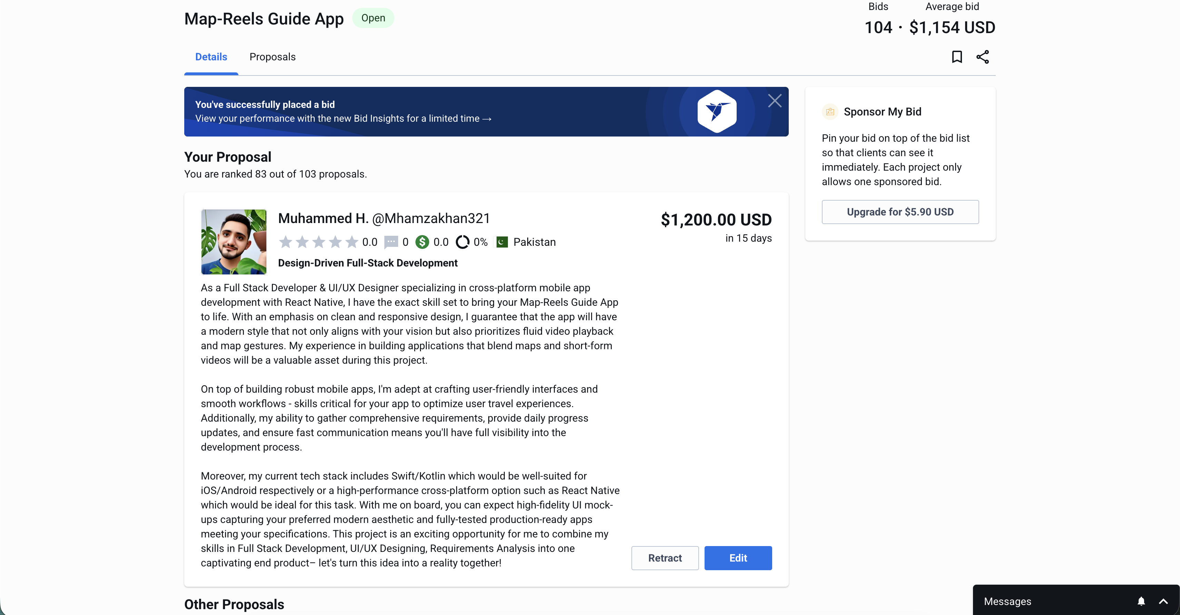

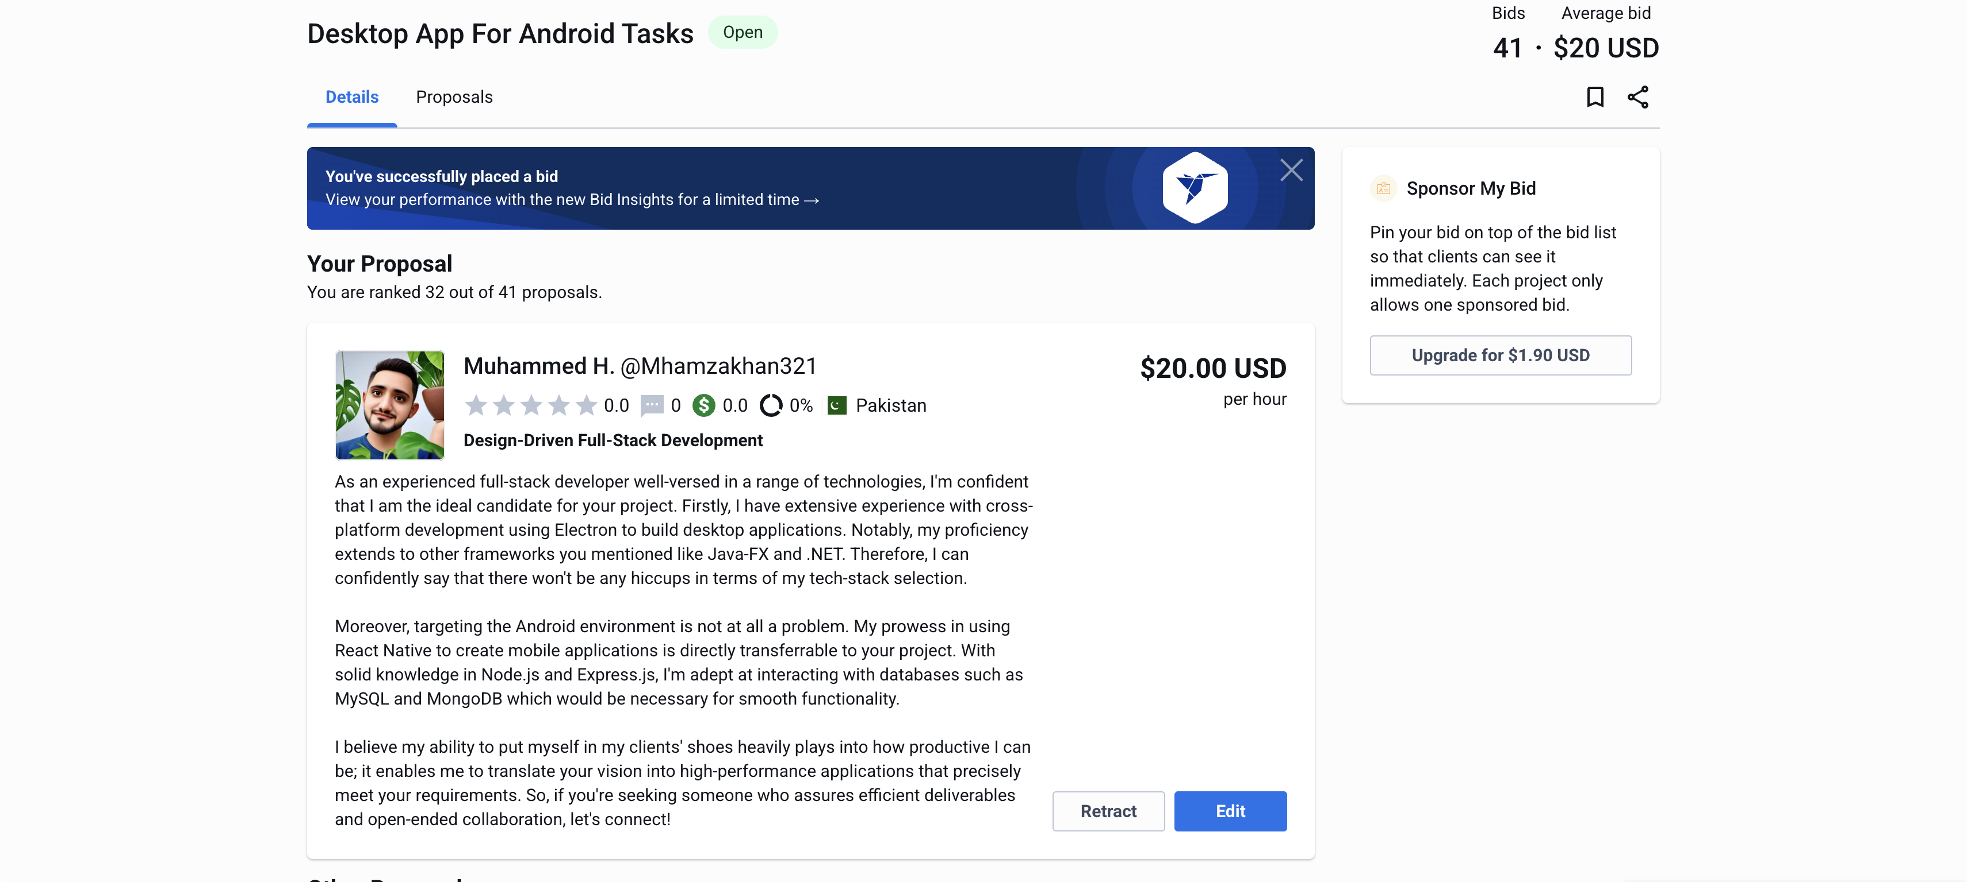

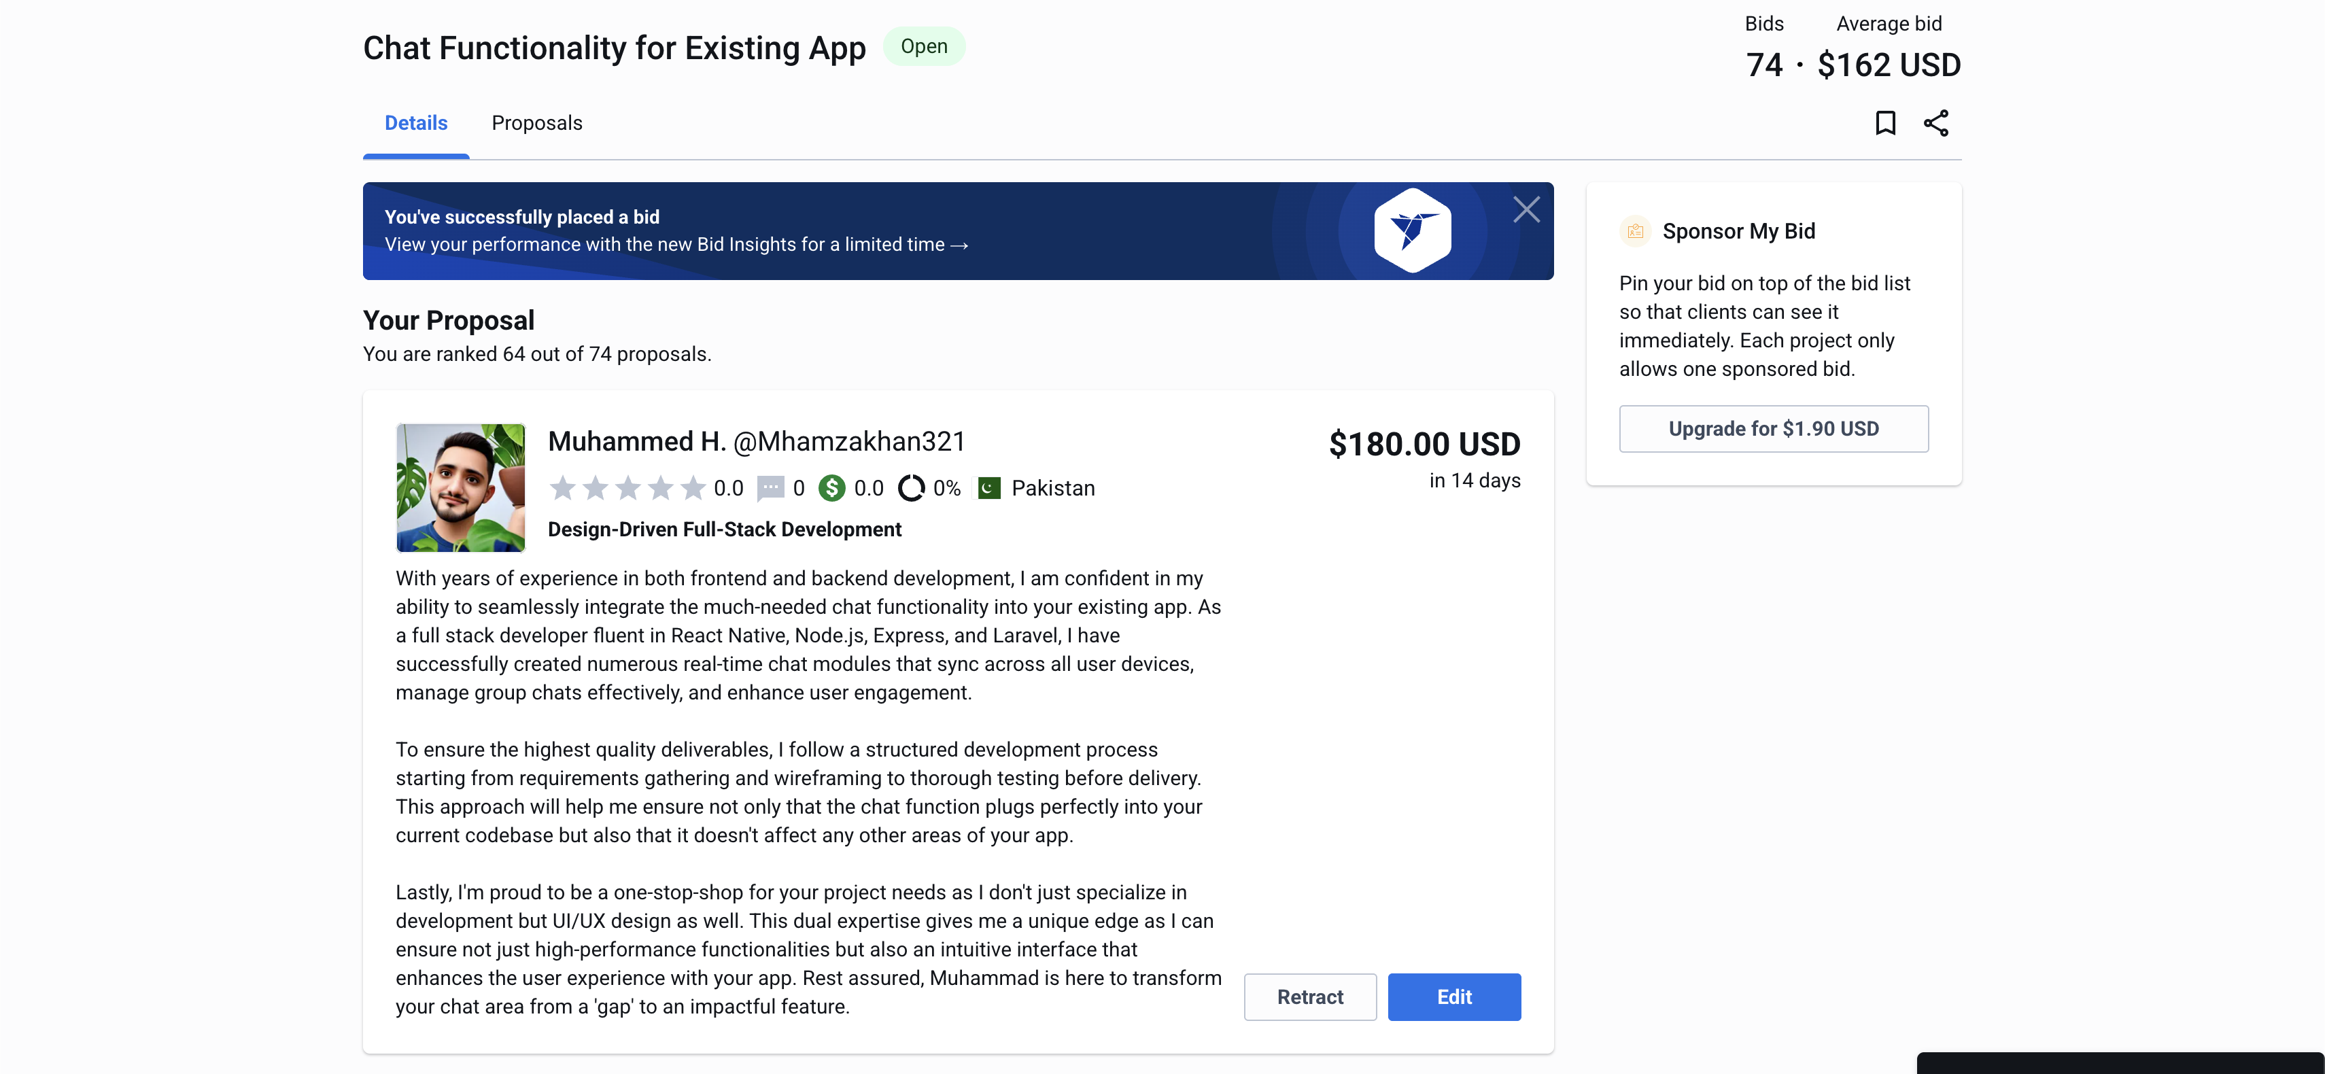

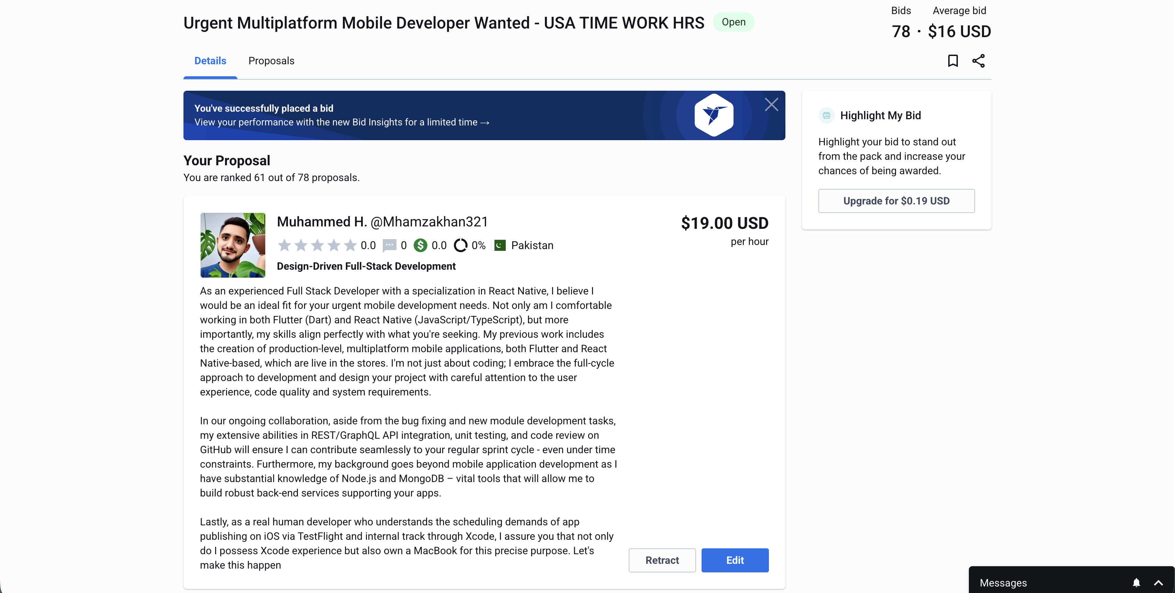

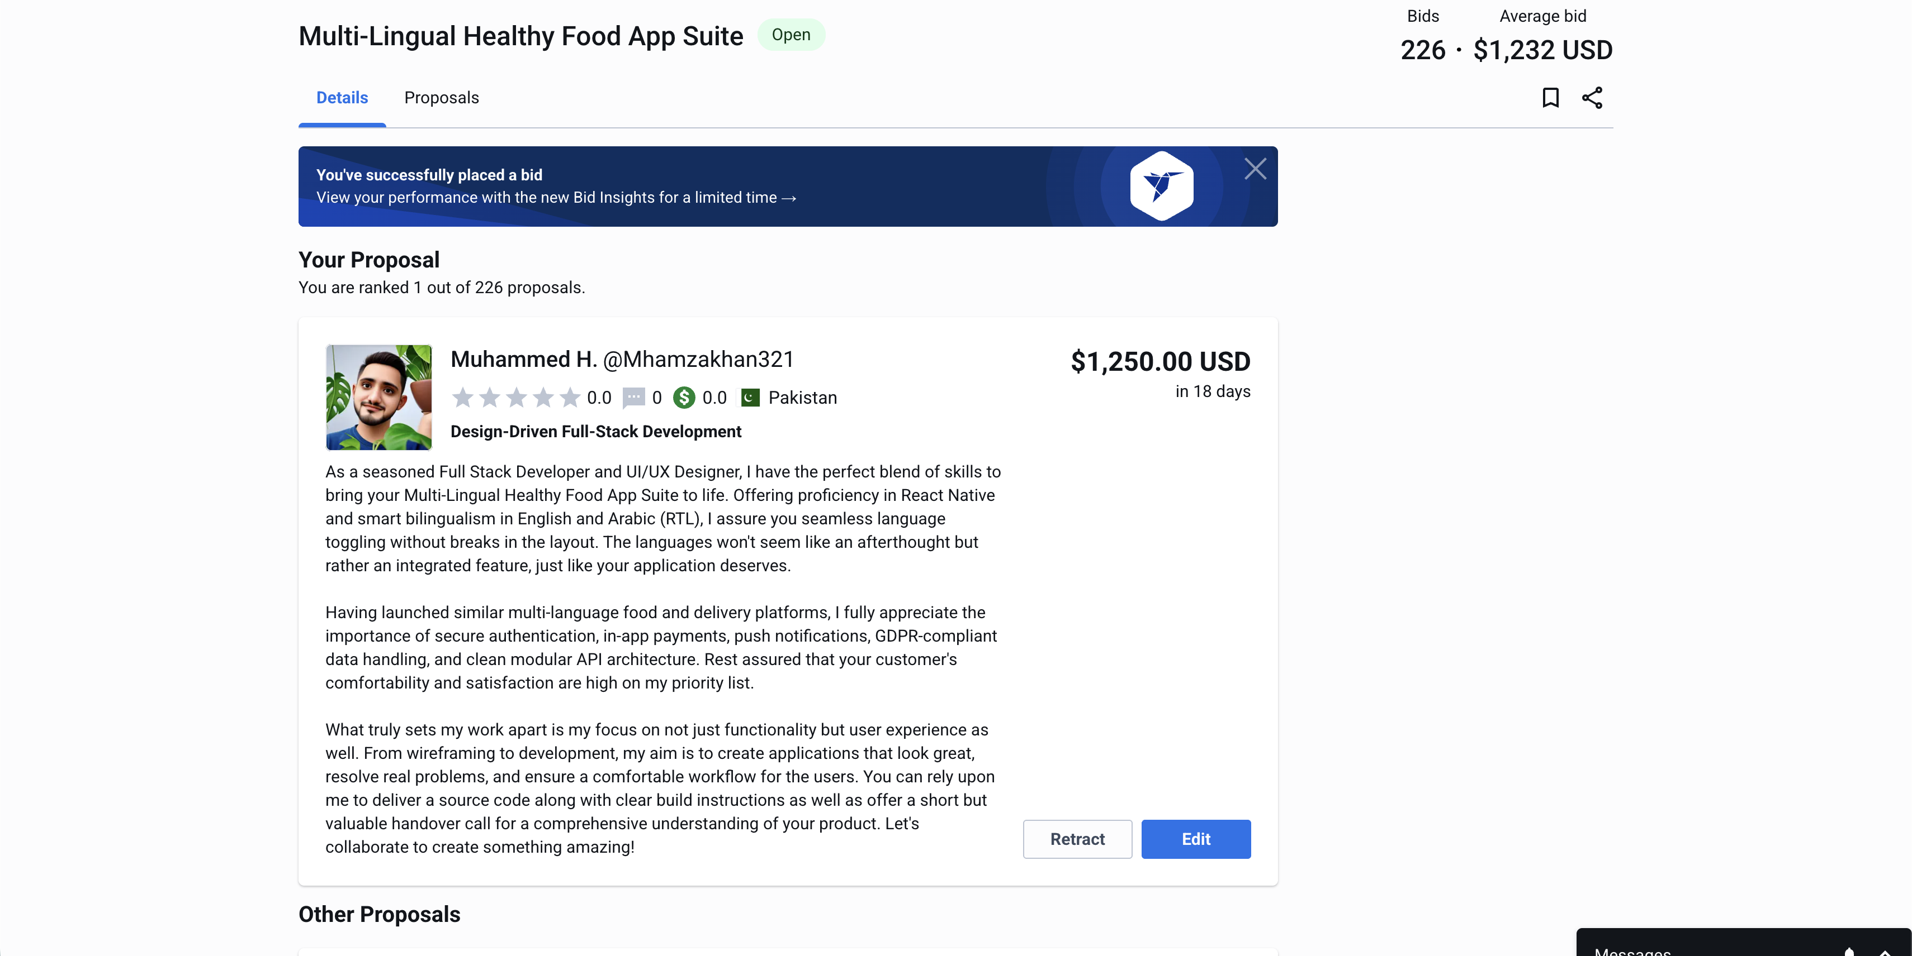

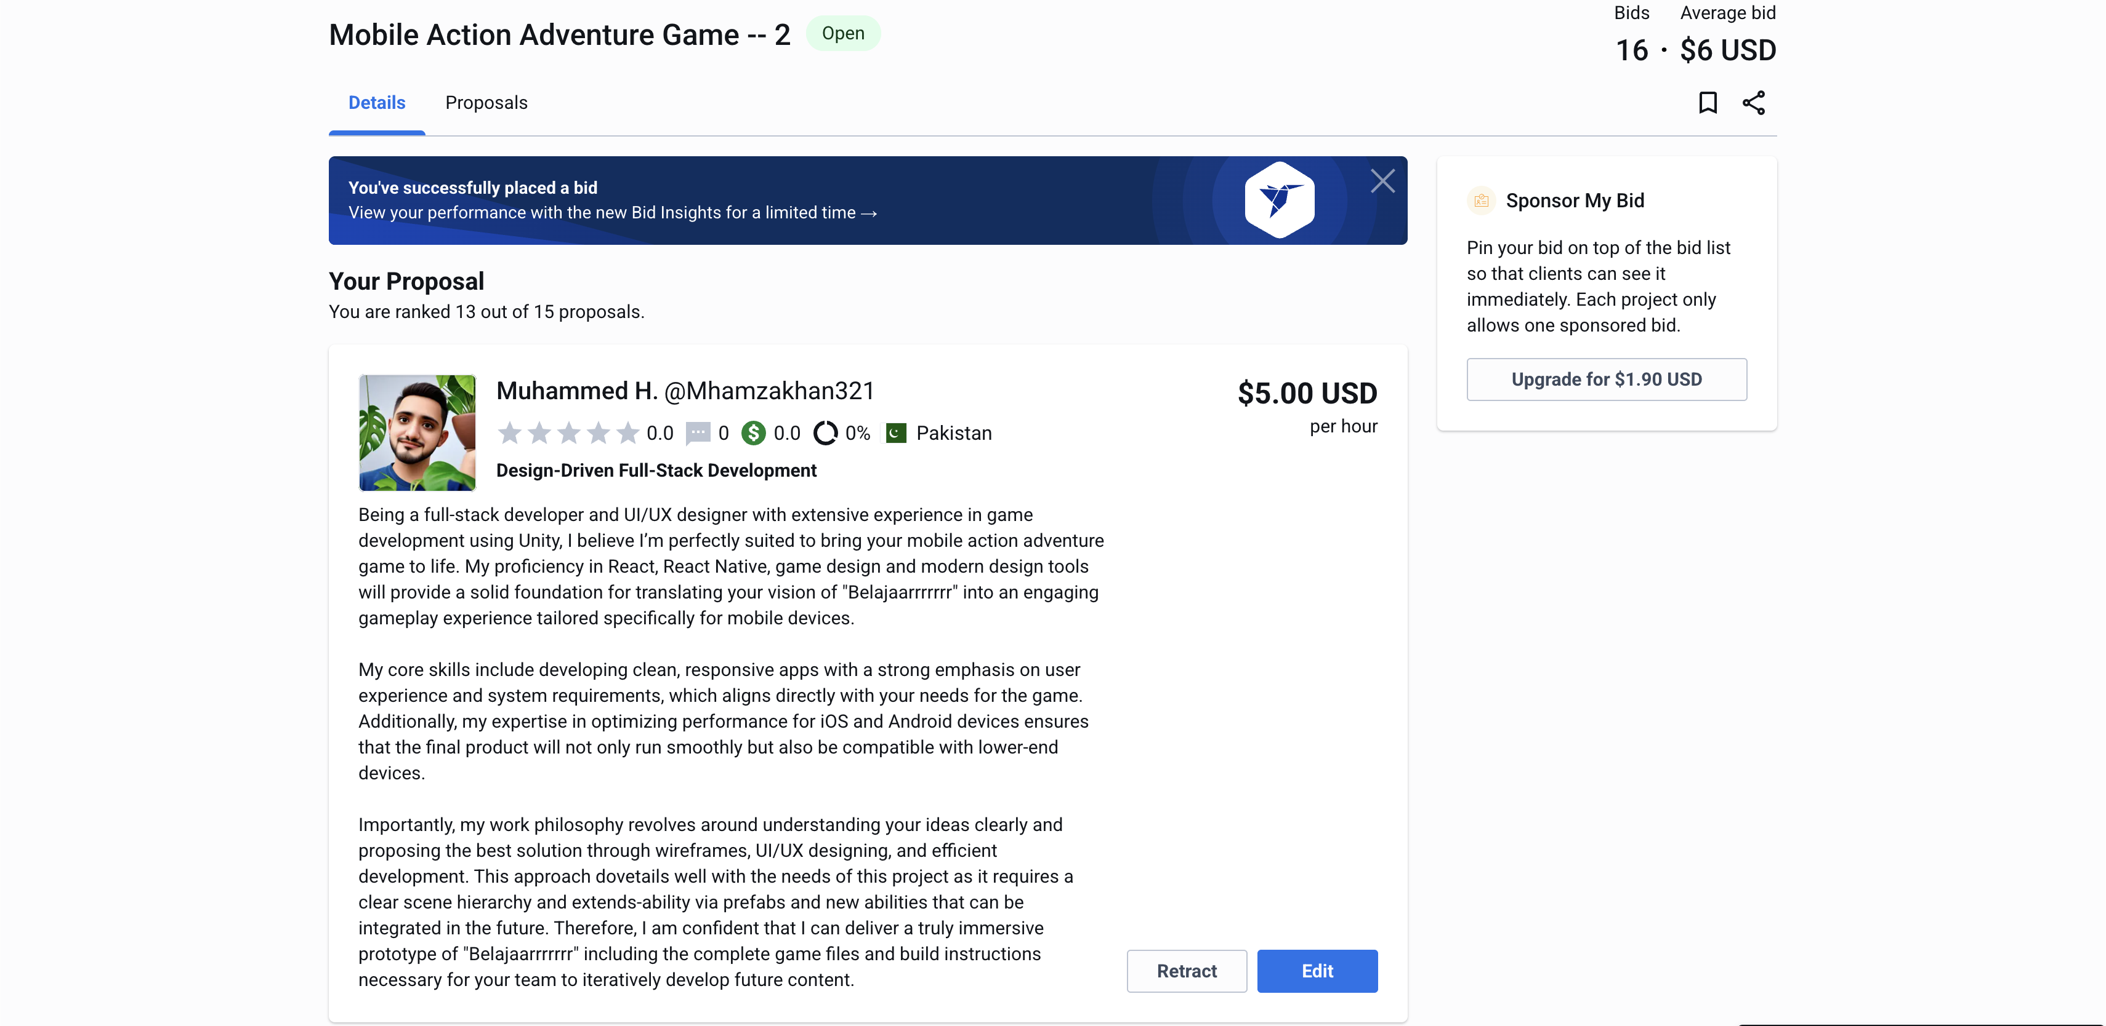

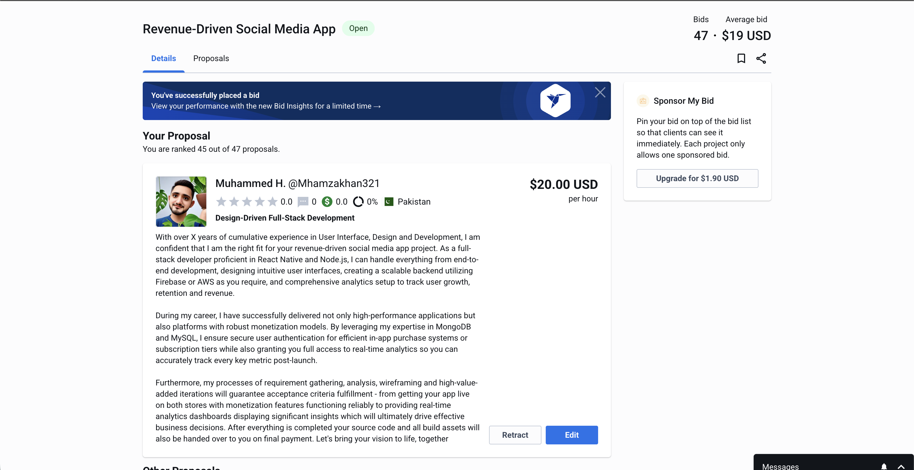

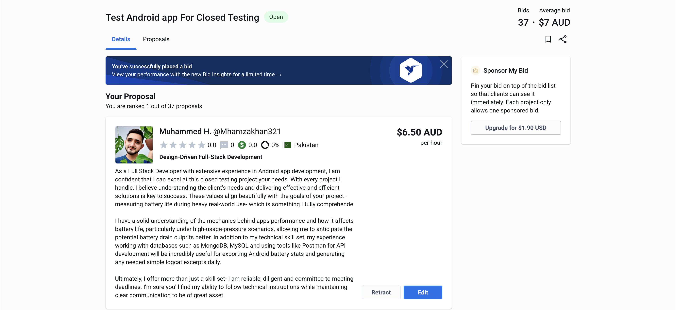

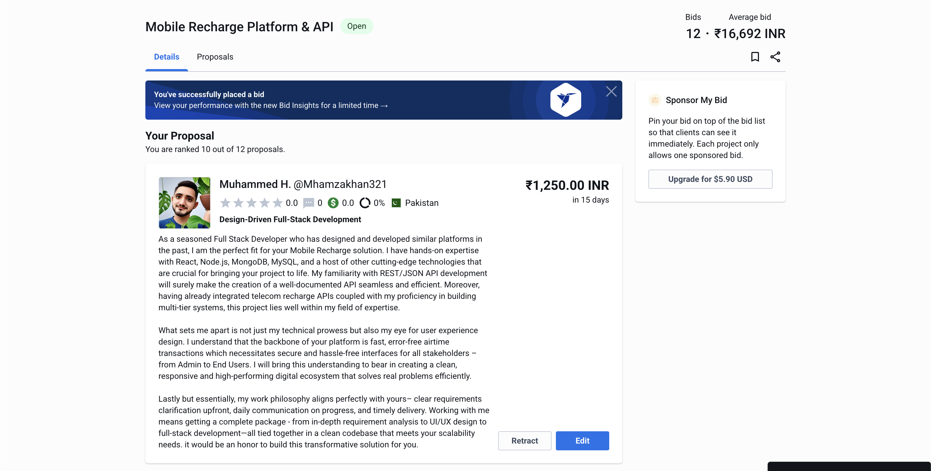

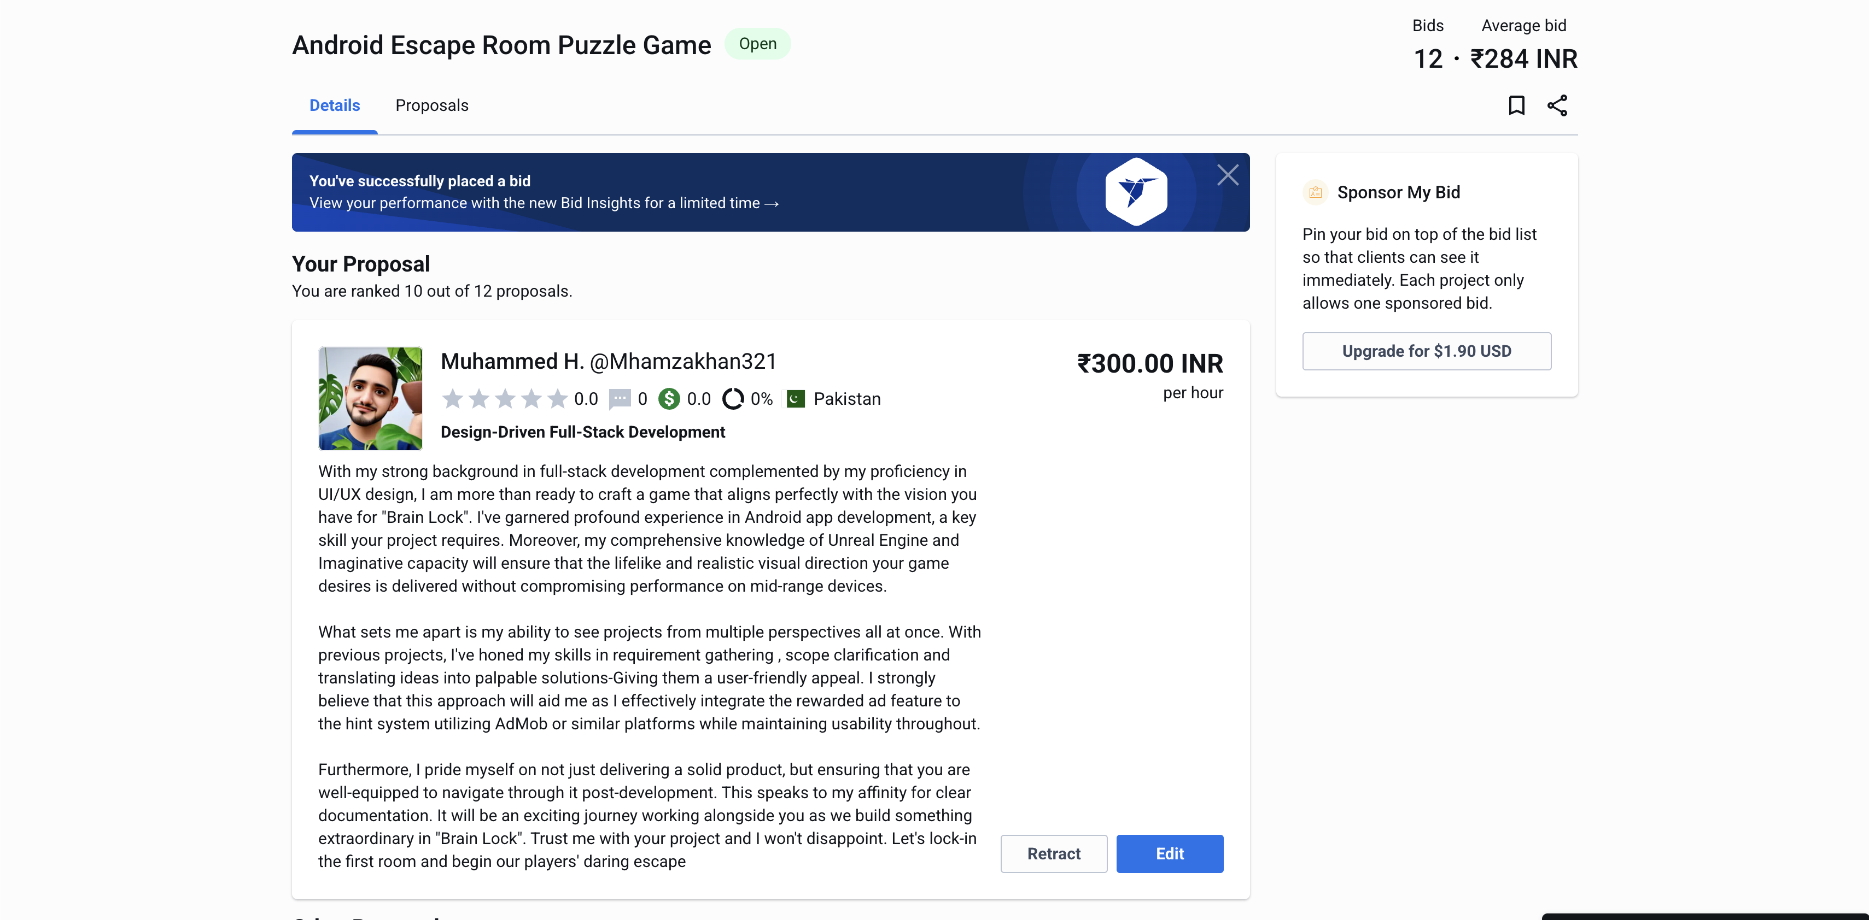

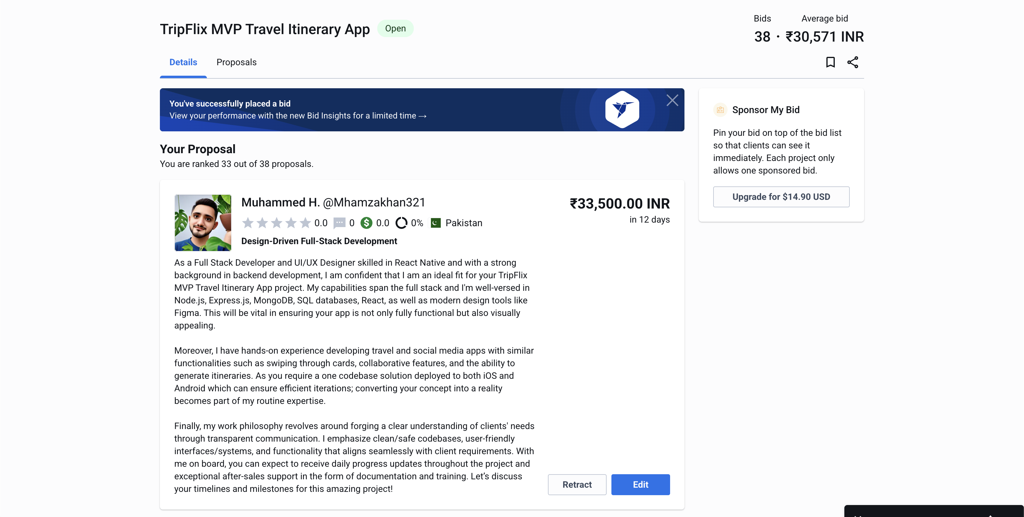

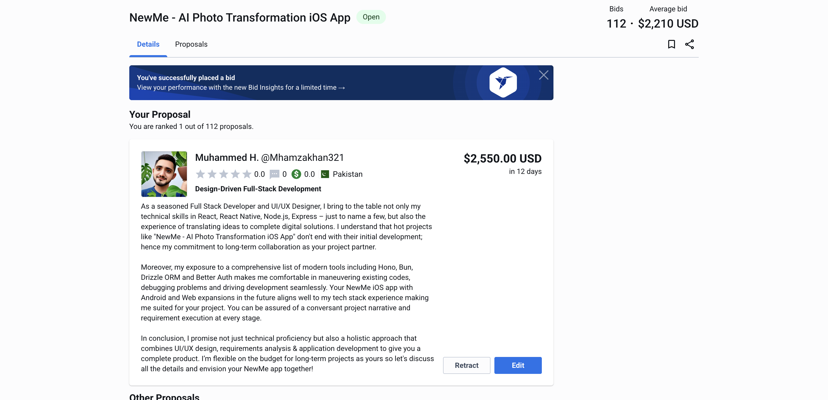

## Part 3: Communication Tracking

Since I received zero responses from clients till now, my communication log focuses on my outgoing attempts and follow-ups.

Attempt 1 (Freelancer.com)

Initial Approach: I offered to all clients for average bids .

Follow-Up: Clients did not respond.

Attempt 2 (Guru – Bid no: 13 )

Initial Approach: Added my experiences

Client likely hired someone with a better proposal and more experience.

## Part 4: Daily Reflections

Day 1 Reflection: 0 responses. Need to adjust low pricing.

Day 2 Reflection: Competition with many experienced campaingners.

Day 3 Reflection: Need more platforms for credibility.

Day 4 Reflection: Some Proposals ranked as number 1.

Day 5 Reflection: Even simple jobs prefer verified freelancers.

## Part 5: Comprehensive Final Reflection

Success Rate: 30%.

Some Proposals are ranked No:1, hope to receive the project soon.

Improvement Needed:

- Need to publish more material for clients to rely on me.

- Should conduct thorough QA tests for better results.

Conclusion: Competition in the market is above par. Need more experience.